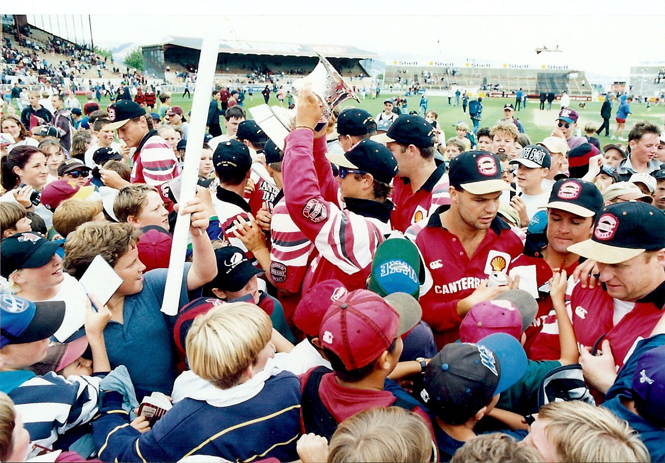

Signing autographs after Shell Cup win Lancaster Park January 1996